Project Name |  | Confidentiality Level
Database Management System |  | Public
Project ID | Version | Document Code
00001 | 1.0 | 00001_1.0_03

Database Management System Software Requirements Specification



Copyright © Ruankosoft Technologies(Shenzhen), Co., Ltd.
. All Rights Reserved
Revision Record
Date | Revision Version | CR ID /Defect ID | Sec No. | Change Description | Author
4.26 | 1.0 |  |  | First | 15301018
Content
1 Introduction 9
1.1 Purpose 9
1.2 Scope 9
2 General description 9
2.1 Software perspective 9
2.1.1 About the Project 9
2.1.2 Environment of Product 9
2.2 Software function 9
2.3 Actors 10
2.4 User characteristics 10
2.5 Assumptions & Dependencies 11
3 Specific Requirements 11
3.1 System Use Case 11
3.2 Database Management 11
3.2.1 Functional Requirements1 12
3.2.2 Drop Database 12
3.3 Table Management 13
3.3.1 Create Table 13
3.3.2 Alter Table 14
3.3.3 Drop Table 14
3.4 Field Managent 15
3.4.1 Add Field 15
3.4.2 Alter Field 15
3.4.3 Drop Field 16
3.5 Data management 16
3.5.1 Insert Record 16
3.5.2 Update Record 17
3.5.3 Select Record 17
3.5.4 Delete Record 18
3.6 Index Management 18
3.7 Client Management 18
3.8 Transaction Management 18
3.9 Integrity Management 18
3.10 Database Maintenance 19
3.11 Security Management 19
3.12 Data Information 19
3.12.1 Data type 19
3.12.2 Integrity 19
3.12.2.1 Entity Integrity 19
3.12.2.2 Referential Integrity 19
3.12.2.3 User-defined Integrity 19
3.12.3 Database file 20
3.12.4 Database Description File 21
3.12.4.1 File Name 21
3.12.4.2 File Structure 21
3.12.4.3 Database information structure 21
3.12.5 Table Description File 21
3.12.5.1 File Name 21
3.12.5.2 File Structure 21
3.12.5.3 Table information structure 21
3.12.6 Table Definition File 22
3.12.6.1 File Name 22
3.12.6.2 File Structure 22
3.12.6.3 Field information structure 22
3.12.7 Record File 22
3.12.7.1 File Name 22
3.12.7.2 File Structure 23
3.12.7.3 Record information structure 23
3.12.8 Integrity Description File 23
3.12.8.1 File Name 23
3.12.8.2 File Structure 23
3.12.8.3 File information structure 23
3.12.9 Index Description File 23
3.12.9.1 File Name 23
3.12.9.2 File Structure 24
3.12.9.3 Index information structure 24
3.12.9.4 Index data file 24
4 Interface Requirements 24
4.1 User Interface 24
4.2 Software Interface 24
5 Overall Design Constraints 24
5.1 Hardware Limitations 24
5.2 Technology Limitations 25
6 Software Quality Attributes 25
6.1 Reliability 25
6.2 Usability 25
7 Requirements Classification 25

Keywords: software requirement specification DBMS users
Abstract:
List of abbreviations: Describe abbreviations in this document, full spelling of the abbreviation and Chinese explanation should be provided.
Abbreviations | Full spelling | Chinese explanation
DBMS | Database management system | 数据库管理系统

Introduction

Purpose
This manual describes requirements from users for functions of the DBMS. The reader includes users, project administrators, testers, designers, developers. The manual focuses on function requirements of DBMS, performance and interfaces of developed software.

Scope
This manual analyzes the logical model of DBMS from users’ perspective. It lists functions and services. The manual omits developments skills and describes user requirements.

General description

Software perspective

About the Project
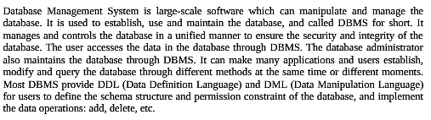.

Environment of Product
This is a windows desktop window program. It stores the data with the file system of the operating system. It can implement the communication between the client and server through the network.

Software function
The function structure diagram is follows:
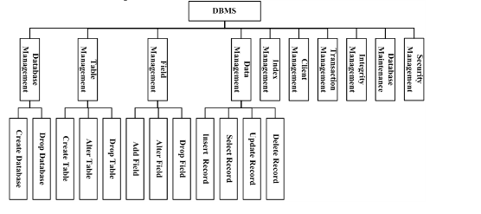
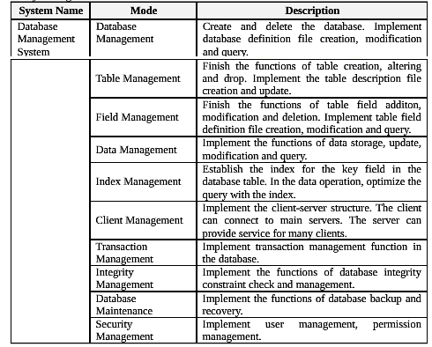

Actors
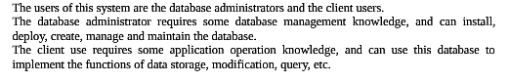.

User characteristics 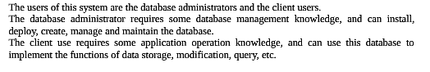

Assumptions & Dependencies

Specific Requirements

System Use Case
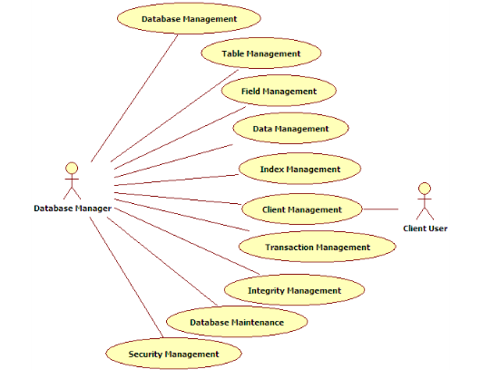

Database Management
1. Sub-module introduction
Create and delete the database. Implement database definition file creation, modification and query..

2. Sub-module use case diagram
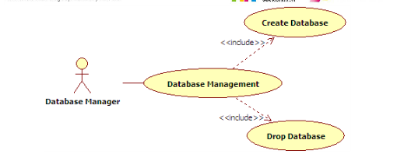.

Functional Requirements1
1. Introduction
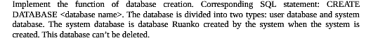
2. Inputs
3. Process
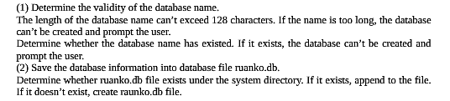
4. Output

Drop Database
1. Introduction
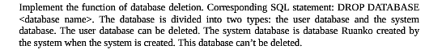
2. Inputs
3. Process
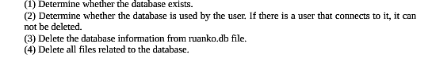
4. Output

Table Management

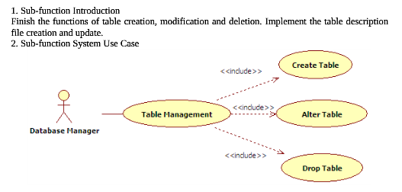

Create Table
1. Introduction
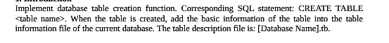
2. Inputs
3. Process
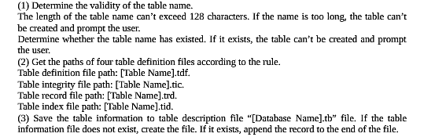
4. Output

Alter Table
1. Introduction
2. Inputs
3. Process
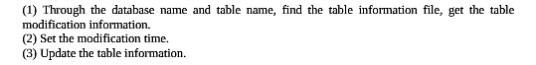
4. Output

Drop Table

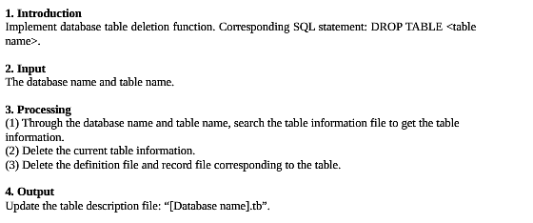

Field Managent
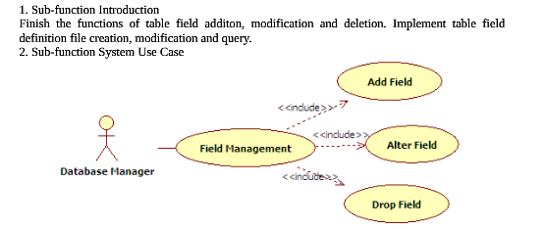

Add Field
1. Introduction
2. Inputs
3. Process
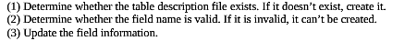
4. Output

Alter Field
1. Introduction
2. Inputs
3. Process
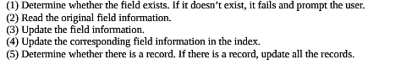
4. Output
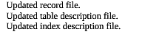

Drop Field
1. Introduction
2. Inputs
3. Process
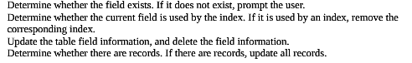
4. Output


Data management

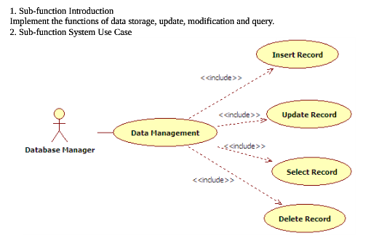

Insert Record
1. Introduction
2. Inputs
3. Process
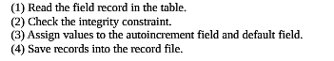
4. Output

Update Record
1. Introduction
2. Inputs
3. Process
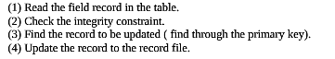
4. Output

Record file.

Select Record
1. Introduction
2. Inputs
Database name,table name
3. Process
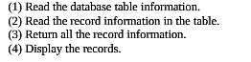
4. Output

Delete Record
1. Introduction
2. Inputs
3. Process
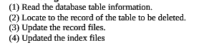
4. Output

Index Management

Client Management

Transaction Management

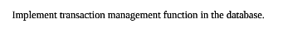

Integrity Management

Database Maintenance

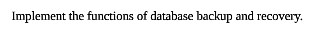

Security Management

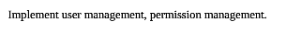

Data Information

Data type

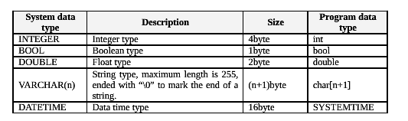

Integrity

Entity Integrity

PRIMARY KEY

Referential Integrity

FOREIGN KEY

User-defined Integrity

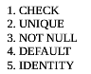

Database file

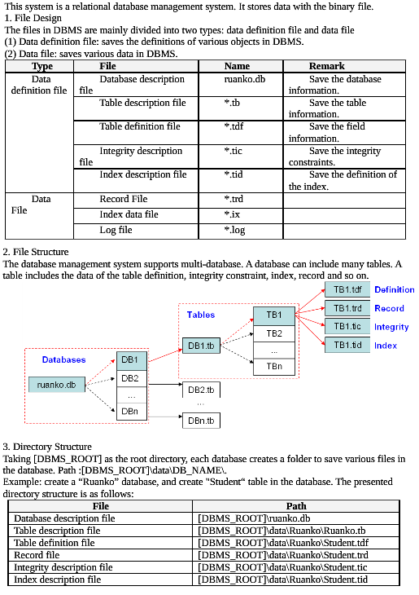

Database Description File

File Name

ruanku.db

File Structure

Database information structure

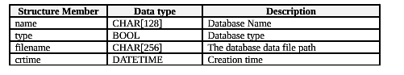

Table Description File

File Name

File Structure

Table information structure

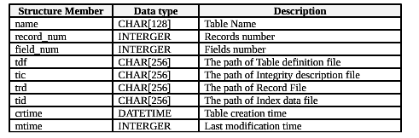

Table Definition File

File Name

File Structure

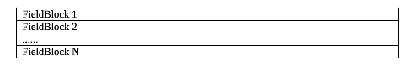

Field information structure

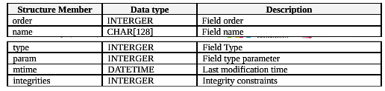

Record File

File Name

File Structure

Record information structure

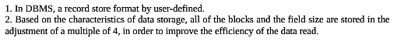

Integrity Description File

File Name

File Structure

File information structure

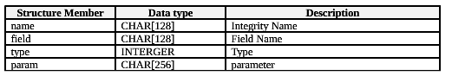

Index Description File

File Name

File Structure

Index information structure

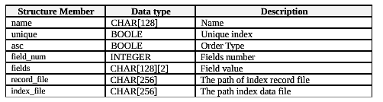

Index data file

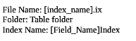

Interface Requirements

User Interface
The resolution is 1024*768 and software interfaces should adapt to the screen dimension.

Software Interface
This is a windows application program with GUI.

Overall Design Constraints

Hardware Limitations
Minimum configuration on a computer:
CPU: 1 GHZ
Memory: 128 MB

Technology Limitations
File format: binary mode file format
Coding standard: C++ Coding standard

Software Quality Attributes

Reliability
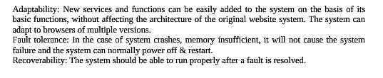

Usability
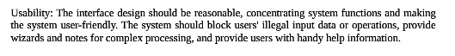

Requirements Classification
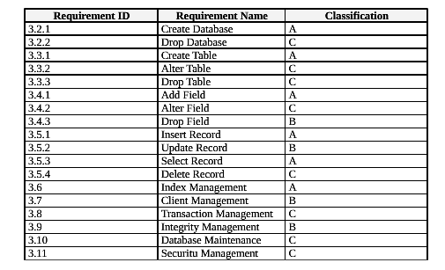
Importance of requirements is classified as following:
A. Mandatory: absolutely essential features, without which the product development will be canceled.
B. Important: unessential features that may affect the viability of the product.
C. Nice to have: desired features, the absence of which will not affect the product viability.

